In Memoriam

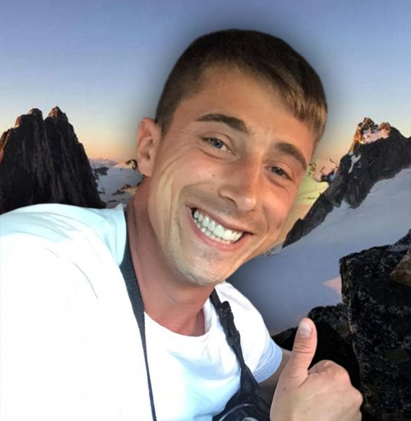
MCpl (Ret’d)
Danny Corneau
19 September 1987- 9 August 2020

St. George’s Chapel, Garrison Petawawa
9 September 2020
1100

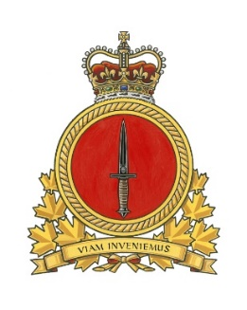
SEQUENCE OF EVENTS

1100- Arrival of dignitaries and the family

National Anthem, O Canada
Opening Remarks, Padre (Maj) Judson Bridgewater

1105- Addresses/ Sharing of Memories
CO CSOR, LCol Michael Laplante
Mother, Ms. Johanne Corneau
Friend and Co-worker, Ms. Candice Price
Reading of the Letters of Condolences

1120- Video Memories

Reading: Psalm 103, Padre (Maj) Bridgewater
Reflection and Prayer of Memorial, Padre (Maj) Bridgewater

Regimental Prayer, WO Ian Luck
Royal Canadian Corps of Signals Prayer, LCol Jay Estrela

1135- Act of Remembrance
Last Post
Moment of Silence
Piper’s Lament, MCpl Michael Ahronson
Reveille

1140- Words of Remembrance- Ms. Melanie Collins
“They shall grow not old, as we that are left grow old;
Age shall not weary them, nor the years condemn.
At the going down of the sun and in the morning
We will remember them.”

ALL: WE WILL REMEMBER THEM.

Royal Anthem, God Save the Queen

1145- Benediction & Departing of dignitaries and the family

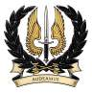

CSOR- Regimental Prayer
You have called us to service in the Canadian Special Operations Regiment, and it is with honour we answer the call. We give thanks for those who have served before us, for the sacrifices they have made and for the example they have set. We ask, as we see to build upon this great heritage, that you bless our members and our families, and endow us with all the qualities necessary to our task: strength, endurance, faith, wisdom, consistency, and valour. As warriors called to serve with humility and honour, we pray for those against whom we are called to flight, and most especially, we pray for those whom we care called to defend. Make us relentless in our service to you, to the world in which we work, and to this great country that we serve. In your most holy name we pray. Amen.

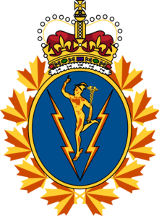

Royal Canadian Corps of Signals Prayer
RCCS Almighty God whose messengers go forth in every age giving light and understanding, grant that we of the Royal Canadian Corps of Signals who spread the word of man to man may be swift and sure in sending the message of thy truth into all the world. May we serve thee faithfully and, with the help of thy Holy Spirit, make such success of our soldierly duties on this earth that we may be found worthy to receive the crown of life hereafter, through Jesus Christ our Lord. Amen.

The family and loved ones are very sad to announce the death of Danny Corneau, husband of Anna Davidovitch, who died at the age of 32, on August 9, 2020, in Montreal.
He lived in Petawawa, Ontario and formerly in Causapscal.
He was the son of Mr. Denis Chiasson and Ms. Johanne Corneau.
Monsieur Corneau is survived by his wife Anna, his son Mathieu, his parents Johanne (Normand "M. Poilu"), and Denis; his sister Karine; his nephew and niece Megan, William; his grandmother Marie-Esther; his uncles and aunts
and all his brothers in the Canadian Army as well as many relatives and friends.

